
Desktop Hero Banner :
1920 x 640

Mobile Hero Banner:
600 x 500

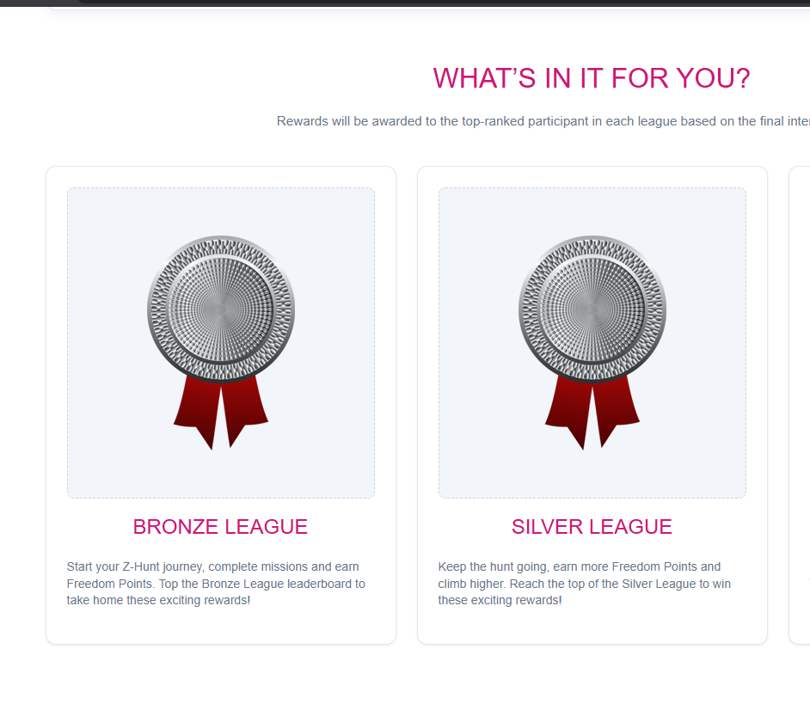

Dimension: (Example – placeholder image)
280 x 300
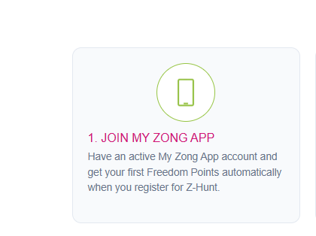

ICON Dimension : ( Example )
150 x 150

